

|  |
| --- |
| NVidia |

**[Technology Sector, Gaming & Semiconductor Industry]**

**NASDAQ Symbol: NVDA**

**Recommendation: BUY**

**Oct. 13 2016**

**Covering Analyst: Arman Hastings**

**NVDA: Highlights**

NVidia is a well-run company perfectly positioned in the booming Semi-conductor and gaming industry. With a calculated intrinsic value of **$71.15** per share and a margin of safety of **6.43**% leads me to believe there is more potential upside to NVidia as they start to create strong positions in other markets. I recommend a **BUY** on Nvidia.

* **Revenue streams from Datacenter and Automotive products have increased by 71.6%)**

CBA realizes efficiencies in logistics and collections through its sole distributor arrangement with A-B. A-B handles all billings accounts receivables, negotiates new distribution agreements, and absorbs all bad debt expenses. CBA has been able to capitalize on such benefits while maintaining autonomy over production.

* **Future massive impact of Deep learning and Artificial Intelligence (AI)**

NVidia has shifted their focus moving forward to larger-scale, more innovative market segments. At NVidia’s GTC China 2017 presentation, CEO Jen-Hsun Huang highlighted the massive impact that deep learning and Artificial Intelligence (AI) will have on the world in the coming years. This will not only help them grow and take over other emerging demands in technology but it will also mitigate any declines in their gaming GPU’s sold.

* **NVidias positioning in developing AI for self-driving cars**

NVidia has very recently procured a contract with Chinese web company Baidu to develop AI platforms for their self-driving cars, adding their name to a client list which already includes industry leaders such as Tesla and BMW. A recent Bank of America forecast suggested that the deep learning and AI market could reach $153 billion by 2020, and NVidia already has a strong position in the industry.

* **NVidia’s very strong fundamentals currently**

Over the last seven years, NVidia has reported positive revenue and net income. Both of these metrics have seen substantial growth as costs have been reduced and profit margins have improved. Since 2010 both the total assets and total capital available have nearly doubled to $7370 million and $4580 million respectively. NVidia has also seen substantial improvements in its ROA, ROC, and ROE. As of FY2016 reporting, ROA is 10.59%, ROC is 17.04%, and ROE is 17.46%.

**Monthly Price Movement**

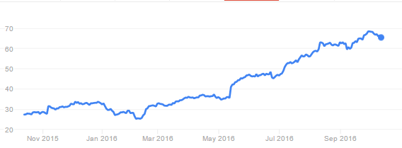

**Investment Style**

|  |  |  |  |
| --- | --- | --- | --- |
| Large |  |  |  |
| Mid |  |  |  |
| Small |  |  |  |
|  | Value | Core | Growth |

***Sources:*** *Morningstar*

|  |  |
| --- | --- |
| **Firm Profile** | |
| **Closing Price 10/13/15** | 65.65 |
| **52-Week Range** | 24.55 – 69.70 |
| **Average Daily Volume(M)** | 9.66 |
| **Shares Outstanding(M)** | 543 |
| **Market Cap (USD)(B)** | 35.22 |
| **Beta** | 1.24 |
| **P/E (ttm)** | 61.51 |
| **P/B (mrq)** | 3.53 |
| **EV/EBITDA (ttm)** | 28.16 |
| **ROE** | 20.50% |

***Sources:*** *Yahoo Finance*

|  |  |  |  |
| --- | --- | --- | --- |
| **Valuation** | | | |
|  |  | **Weight** | **Percent of Current Price** |
| **DCF** | 72.67 | 80% | 108.71% |
| **Historical** | 67.24 | 20% | 100.40% |
| **Relative** | 23.86 | 0% | 35.86% |
| **Intrinsic Value** |  | **71.56** |  |

***Sources:*** *Team estimates*



5 Year comparison of total return amoun Nvidia S&P 500 Index and the S&P Semiconductor Index

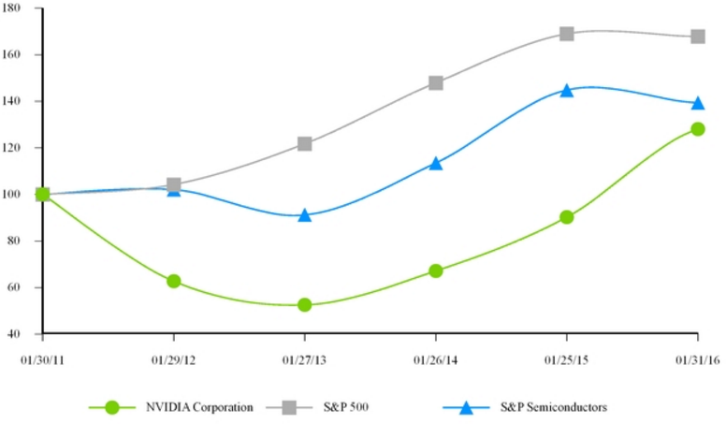

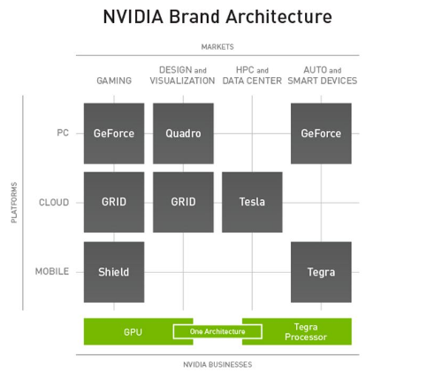

**Business Description**

**NVidia** (NVDA) is the world leader in visual computing. Nvidia founded in 1993 and later invented the Graphics Processing Unit (GPU) in 1999 which makes the beautiful graphics we see today possible in films, and video games. It enabled amazing creativity and progress within artificial intelligence, design and autonomous cars. Nvidia also has products in other segments such big data analytics. Nvidia’s foundational revenue stream is in its gaming-oriented PC GPU products. Despite diversification into other market segments, this product division still remains dominant and the largest revenue-generator for Nvidia.

**Business Segments**

Nvidia has two reporting segments**: GPU, and Tegra Processor** to make up their unified business archtecture

Nvidia’s foundational revenue stream is in its gaming-oriented PC GPU products.

**GPU Related:**

* **Gaming:** Nvidia’s gaming products range from PC, Cloud, and Mobile gaming products and GPU’s. Nvidia’s most popular PC gaming product is their GeForce GPU’s the best pc gaming graphics available. Nvidia’s other gaming products inclue the Nvidia Grid that provides the power if NVidia graphics throughout the cloud, and Nividia’s Shield mobile gaming GPU’s. Nvidia’s Shield product allows an android gaming device to enjoy the digital content in the cloud.
* **Design and Visualization:** Nvidia’s Design and Visualization products range from PC to Cloud products and GPU’s. Nvidia’s PC product for Visualization and design is the Quadro which is a line of GPU’s that are for professionals working in computer-aided design, video editing, special effects and other applications. Nvidia’s Grid cloud product also is used and marketed towards the design and visualization field.

**Tegra Processor Related**

* **HPC and Data Center:** Nvidia’s HPC and Data Center product is by cloud service made with Tegra processors. That cloud service is called Tesla and is used for supercomputing and big data applications. The Tesla service by Nvidia though should not be confused with the Tesla Auto Company, even though Nvidia does provide products for Tesla the actual electric automobile company.
* **Auto and Smart Devices:** Nvidia’s Auto and Smart Devices products range from PC to mobile Tegra processors. Nvidia’s GeForce product can also have Tegra Processors for mainly automobiles. Nvidias Tegra processors can also be used for mobile smart devices and notebooks.

**Strategy**

NVDA has some clear strategic goals for the future, that will aid or allow them to keep their strategic advantage over their competitors:

**To extend technology leadership in visual computing.**  Nvidia believes that visual computing is fundamental to the continued expansion and evolution of computing. Their research and development resources are used to extend their leadership in visual computing allowing Nvidia to enhance their user experience for consumer entertainment and professional visualization applications.

**To extending visual computing leadership into mobile and cloud-computing platforms** Nvidia believes that visual computing will remain a key component in the computing issues surrounding mobile, cloud and software as a service. That is why Nvidia seeks to enable interactive graphics applications (e.g. games, movie, photo editing, and design software) to be accessed by any device, anywhere with their cloud and mobile products.

**Continue to revolutionize computing with the GPU’s parallel processing capability.** One of the main development issues for the technology sector as a whole is improving computing with GPU’s parallel processing capability. We are hitting a point in technology where the complexity of hardware products are out growing the complexity of developed software to fully unlock the potential of our current day hardware products. Therefore Nvidia is not only perfectly positioned to revolutionize computing with improvements for parallel processing, they are activity perusing it, and can implement massive improvements almost instantaneously with their processor hardware. Nvidia also believe that the massively parallel processing capabilities of Nvidia GPUs can solve complex computational problems in significantly less time and with less power consumption than a CPU.

To do this Nvidia is working with developers worldwide who write programs for the CUDA platform using various high-level programming languages. Developers are able to accelerate applications in areas ranging from molecular dynamics to image processing, derivatives modeling for financial risk analysis and big-data analytics.

**Protecting intellectual property, and using it to enter into license and development contracts.**  Nvidia believes their intellectual property portfolio is a valuable asset that can be monetized by licensing their technology to customers and partners that desire to build such capabilities directly into their own products. Such license and development arrangements can further enhance the reach of their graphics and mobile technology and is entirely essential when competing in the computer science research field.

**Enabling visual computing platforms in key focus areas.**  NVidia feel that they are well-positioned to use their expertise in visual and parallel computing to make contributions in four key markets where their visual computing expertise is valued:

**-Gaming:** To use advanced graphics technologies to create a range of gaming platforms, stretching across PCs, mobile devices and the cloud.

**-Professional Visualization:** To continue to serve their customers while working closely with independent software vendors to optimize their offerings for Nvidia GPUs.

**-Datacenter**: Nvidia’s strategy is to serve growing demand for deep learning, big-data analytics and scientific computing.

**-Automotive:** Their strategy is to utilize Tegra’s visual computing capabilities to augment the driving experience, as well as leverage their significant supercomputing capabilities to accelerate autonomous driving. Nvidia currently has 50 companies designing with their Nvidia Drive PX hardware.

**Industry Overview**

Nvidia specializes in markets in which visual computing and accelerated computing platforms are important. These platforms incorporate hardware, systems software, programmable algorithms, systems and services to deliver value that is unique in the marketplace. Below are most of Nvidias approach to the variety of the specialized markets.

**Gaming**

Computer gaming is one of the largest entertainment industries propelled by the launches of new gaming titles, the rise of eSports, and the new realm of virtual reality. Nvidia’s GPUs enhance the gaming experience by improving the visual quality of graphics, increasing the frame rate for smoother gameplay and improving realism by replicating

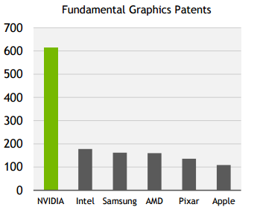

Types of Currrent Nvidia Drive Px Users

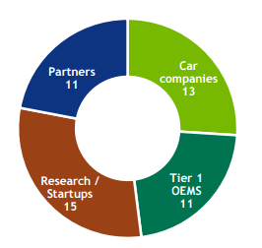

Nvidia Revenue from Gaming Related Sales

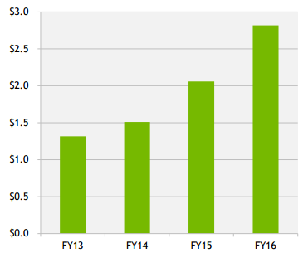

Expansion of GPU Deep learning Across Industry Fields

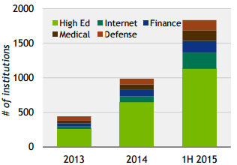

the behavior of light and physical objects. These can be enjoyed independently or together to extend the gaming experience across platforms.

Nvidias gaming platforms utilize sophisticated 3D software and algorithms including their GameWorks investment in real-time graphics and simulation. These software products enables Nvidia to deliver realism and immersion, even when playing games remotely from the cloud. Nvidia further enhances gaming with GeForce Experience, their gaming application that optimizes the PC user’s settings for each title and enables players to record and share their victories. It has been downloaded by more than 70 million users.

Their products for the gaming market include GeForce GTX GPUs for PC gaming, the SHIELD family of tablet and portable devices for mobile gaming, GRID for cloud-based streaming on gaming devices, and development services for gaming platforms.

**Professional Visualization**

Nvidia serves the Professional Visualization market by working closely with independent software vendors to optimize their offerings for Nvidia GPUs. Their visual computing solutions enhance productivity for critical parts of the workflow for such major industries as automotive, media and entertainment, oil and gas, and medical imaging - where their GPUs improve productivity and introduce new capabilities.

For designers who build the products we use every day, it is critical that what they see digitally mirrors reality. This requires simulating the physical behavior of light and materials, or physically-based rendering, an emerging trend in professional design. Nvidias Iray and DesignWorks software delivers this to designers. They enable an architect designing a building with a computer-aided design package to interact with the model in real time, view the model in greater detail, and generate photorealistic renderings for the client. And they enable an automotive designer to create a highly realistic 3D image of a car, which can be viewed from all angles, reducing reliance on creating costly, time consuming, full scale clay models.

Just as virtual reality is becoming more important in gaming, there is a growing number of enterprise applications within medicine, architecture, product design and retailing will also need solutions for virtual experiences. Virtual car showrooms, surgical training, and bringing historical scenes to life are early examples of this technology deployed.

**Datacenter**

The Nvidia Tesla accelerated computing platform greatly increases the performance and power efficiency of high-performance computers and datacenter systems by applying the parallel-processing of GPUs and enabling software to solve general-purpose computing problems. Tesla-based servers and supercomputers increase the speed of applications used in such fields as aerospace, bio-science research, mechanical and fluid simulations, energy exploration, deep learning, computational finance and data analytics.

Accelerated computing is recognized as the path forward for high performance computing amid the slowing of Moore’s Law (the law which postulates the doubling of transistors every 18-24 months). The proportion of supercomputers utilizing accelerators has grown sharply over the past five years, now accounting for one-fifth of the systems on the Top 500 list and one-third of the list’s total floating-point operations per second. Tesla GPU accelerators power the fastest supercomputers in the United States, Japan and Europe. They will also drive the U.S. Energy Department’s next generation of supercomputers at Oak Ridge and Lawrence Livermore National Laboratories.

Tesla has had a significant impact on scientific discovery, including improving heart surgery, HIV research and mapping human genome folds. Tesla GPUs and our cuDNN software have been broadly adopted for deep learning, a new computing method for enabling artificial intelligence. Deep learning enables computers to learn for themselves and perform tasks, like recognizing images, text and speech - in some cases better than humans. Leading web-services companies are using GPUs to improve consumer cloud services. The use of deep learning is growing rapidly in many industries, automating such tasks as reading medical imaging, surveying coral on the sea bottom and robotically

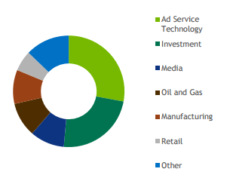

Deep Learning for Enterprise Applications

“Deep learning for Enterprise Applications”, 2015 Tracica

thinning lettuce harvests to maximize crop yields.

NVidia also serves the Datacenter market with GRID for virtualized graphics. GRID makes it possible to run graphics-intensive applications remotely on a server in the datacenter, instead of locally on a PC or workstation. Applications include accelerating virtual desktop infrastructures and delivering graphics-intensive applications from the cloud.

**Automotive**

The automotive technology market has grown tremendously as the car itself is becoming a powerful computer. Cars will feature a multitude of devices, driven by sophisticated software algorithms. These devices will be designed to ensure the drivers safety and the safety of those around them, enhance comfort and enjoyment, and search and navigate. They will use the tools of deep learning to sense their environment, ultimately driving themselves.

NVidia’s products are in more than 10 million cars on the road today, powering infotainment, navigation and virtual cockpit systems from a broad range of automakers.

Beyond Automotive, NVidia sees the opportunity for Tegra in other embedded areas where visual computing is valued. Examples include robots that respond to voice and gesture commands, drones that process enormous amounts of visual-based data and smart monitors powered by Android that make a PC optional.

**Competitive Positioning**

**Competitive Advantage**

NVidia has a foundational competitive advantage of being the creators of the GPU’s. NVidia is also the market leader for sales of GPU’s with their only real competition currently being AMD. They do with by creating consistent, and better preforming products.

NVidia also has much more invested in research and development than their direct competitors. The other competitors (AMD, and other private GPU suppliers) do not have as much as NVidia does in their development technologies. This is also the main result of NVidias better processor cooling, lower power consumption and overclocking potential.

Lastly the other products and services they have started will start to come into great demand in the near future. NVidias projects on Cloud computing, AI, Deep learning, Automobile software and others are cutting edge products that will be important to our near future.

The market for semiconductor products is intensely competitive and is characterized by rapid technological change, evolving industry standards and declining average selling prices. Therefore NVidia believe the principal competitive factors in this specific technology sector are performance, breadth of product offerings, software support, conformity to industry standard Application Programming Interfaces, manufacturing capabilities, and processor pricing. NVidia believes that their ability to remain competitive will depend on how well they are able to anticipate the features and functions that customers will demand and whether NVidia is able to deliver consistent volumes of our products at acceptable levels of quality at competitive prices. NVidia expect competition to increase from both existing competitors and new market entrants with products. NVidia also expects those products to be less costly of their however they are prepared to take that one with

better performance and/or additional features not provided by the alternatives. In addition Nvidia is also aware that new competitors or alliances among competitors could emerge and acquire significant market share from them

**SWOT Analysis**

Nvidia is a well-known player in the computing industry with its products across a variety of applications. In such a rapidly changing industry Nvidia has definitely positioned it’s self amazingly in the gaming and processor market and are much deserved of their success. That with their popular branding and advertising Nvidia is definitely the best, and most admired processor product available. With that Nvidia should be unstoppable when striving for their goals, as again they were the first and favorite market movers/creators of GPU processors.

**Strengths**

* A Strong Market position and popular branding & advertising
* Good product mix in graphical processing units.
* Top performers and well known for their GeForce, Quadro, Tegra, and Tesla lines.
* Ability to innovate and innovate successfully.
* Software changes are easy to develop and integrate when their GPU’s and Tegra’s are already widely implemented. This allows Nvidia to easily bully out and semiconductor and software development teams (for semiconductors).

**Weaknesses**

* Intense competition and change within the fast pace sector
* Interest rate increases as they just started taking on short term debt
* Majority of revenue from their GeForce GPU line

**Opportunities**

* Opportunities in automobile growth as more cars are equipped with computers, screens and eventually artificial intelligences for driving.
* Growing industry desire for Deep Learning, Artificial intelligences, and super computing
* Increase in the Cloud Computing market
* Innovation for PC, Mobile, and cloud products and services

**Threats**

* Intense GPU competition from other major brands.
* Economic slowdown and fluctuations
* Reduction in general technological development
* Reduction in market share

**Porter’s Five Forces**

Five Forces analysis evaluates the five factors that determine industry competition.

Rivalry Amongst Sellers | **Mildly Attractive**

This industry is highlly competitive in nature however there are only a handful of players in some of the segments. Major players include Qualcomm, ARM, Texas Instruments, and AMD. Firms compete on differentiation like preformance, power comsumption, and life expectancy. However with high entrance barriers firms can have the time to solidify their position into the industry and then can be safe from inexperienced entrants, and customers that face high switching costs.

Threat of Substitutes | **Very Attractive**

There are no immediate substitutes available for the majority of the semiconductor industry. However new materials such as Molybdenite and Graphene pose a threat of semiconductor substitutions. Graphene described as

world’s thinnest, toughest, and most conductive material may replace silicon ships inthe future. Molybdenite is another substance with potential toperform better than silicon. With Nvidia being as big as they are with the market exposuer they have with GeForce GPUs they should be well poised to maintain or make any changes.

Power of the Suppliers | **Very Attractive**

The supplier, Nvidia have low power of bargaining and already have established products on the market. The semi conductor environment is also characterised by a high about of suppliers striving to be similar or the next Nvidia, Qualcom or Microsoft.

Threat of New Entrants | **Very Attractive**

One of the best parts of being at the top of the semiconductor business is that there are high start up costs that require significant investments. Human capital is very expensive as these developers and designers are sought after. Warehousing and building of the product is very difficult and expensive includeing that the industry is progressing at a rapid pace hence a high risk of obsolesence. Lastly Maintaining intellectual property and not infridging on other intellectual property is insanely dificult and expensive if persued.

Power of the Buyers| **Unattractive**

Buyers pose a backward integration risk (example Samsung makeing its own chips). Buyers have significant leverage on price as they are typically high volume purchasers. Lastly information for buyers are highly avalable and require high up keep, and product consistancy.

**Competitors**

There are many competitors in the industry however there is only a very small handful of competitors that directly compete with Nvidia. There also are large amounts of the competition that are hard to find, and are still not publically available for trading. However with Nvidia’s branding, first movers advantage, and innovation is hard to find competitors are even close to what Nvidia exactly does.

**Current Competitors**

A significant source of competition comes from companies that provide or intend to provide GPUs and mobile SOC products. Including:

* Any supplier of discrete and integrated GPUs, including supercomputers and chipsets that incorporate 3D graphics functionality as part of their existing solutions e.g. Intel, and AMD.
* Any supplier of SOC products that support tablets, smartphones, and PCs as well as products that are embedded into smart devices such as televisions, monitors, gaming devices and automobiles e.g. AMD.
* Any licensors of graphics technologies or suppliers of cellular base bands e.g. ARM and Imagination Technologies Group

***Intel***

Intel is an American multinational technology company headquartered in Santa Clara, California. It is one of the worlds largest and highest valued semiconductor chip makers based on revenue. Intel tends to focus it’s product line on its CPUs and other series of microprocessors. Some of these products include motherboard chipsets, network interface controllers and integrated circuits, flash memory, graphics chips, embedded processors and other devices related to communications and computing. They do sell GPU’s but not to the caliber of AMD or NVDA. However Intel is much bigger in size and revenue, sitting at a massive amount of 55.35 Billion annually while Nvidia takes in 5 billion of revenue while lastly AMD takes in only 1 billion of revenue.

Improved revenue diversification from last year with growth in large markets

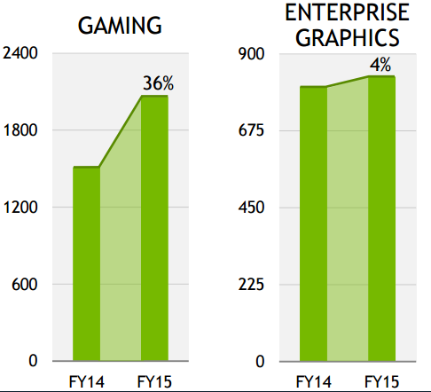

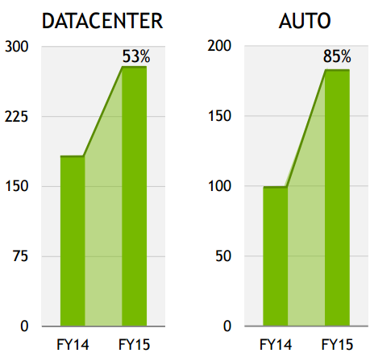

***Qualcomm***

Qualcomm is an American multinational semiconductor and telecommunications equipment company that designs and markets wireless telecommunications products and services. It derives most of its revenue from chip making and the bulk of its profit from patent licensing businesses.

***Advanced Micro Devices.***

Advanced Micro devices is also an American multinational semiconductor company based in Sunnyvale, California, United States, that develops computer processors and related technologies for business and consumer markets. AMD's main products include microprocessors, motherboard chipsets, embedded processors and graphics processors for servers, workstations and personal computers, and embedded systems applications similar to Intel and Nvidia. They are also currently Nvidias biggest competitor when it comes to GPU’s. As it currently stands AMD and Nvidia have dominated the GPU market. However AMD in comparison to Nvidia sells a larger variety of chipsets than Nvidia does.

**Financial Analysis**

**Robust Growth in Revenue and Revenue diversification**

Again despite Nvidia’s diversification their foundational revenue stream is in its gaming-oriented PC GPU products. Despite diversification into other market segments, this product division remains the largest revenue-generator for Nvidia. However this relative revenue segment has been declining as Nvidia has expanded into their other product areas. Since their Q1 2016 report (4-26-2015), revenue streams from Datacenter and Automotive products have increased by 71.6% and 54.55% respectively. Nvidia also generates a significant portion of its revenues from Professional Visualization and OEM & IP products as well. Combined, these segments represent roughly 25% of Nvidia’s revenue. It is worth noting that over the last six quarters the revenue generated from OEM & IP products has declined 25.22% while the revenue from Professional Visualization products has increased by 18.2%.

Regionally, Nvidia still derives most of its revenue from the Asia Pacific markets. In Q2 2017 (7-31-2016), revenue in the Asia Pacific region accounted for 66.67% of overall revenue. This is compared to 14.42% from the US, 11.69% from Europe, and 7.21% from Other Americas. There has been stable revenue growth from every region over the last six quarters, keeping in line with the growth in overall revenue. The largest regional growth can be seen in the Asia Pacific and United States regions, indicating improving consumer demand in both of these areas.

Such as pushing the boundaries of AI and deep learning technologies. Their first step is with their new GPU architecture, Pascal. Nvidia’s latest line of GPUs for both consumer and commercial use have been hailed as the best performing processors on the market.

**Gross Margin Expansion**

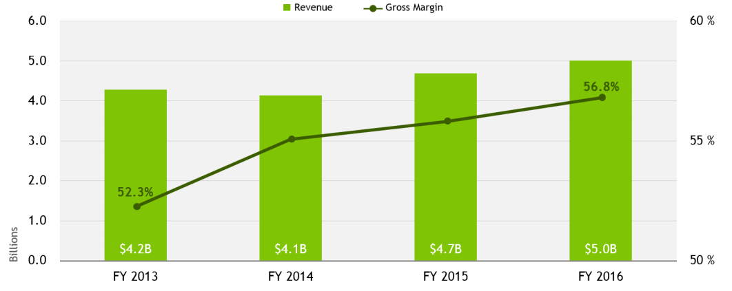

https://i.gyazo.com/30a481279f7bcecd6d60e3ca6f67db23.png

**Solid Net Income as well as Revenue**

Over the last seven years, Nvidia has reported positive revenue and net income. Both of these metrics have seen substantial growth as costs have been reduced and profit margins have improved. Since 2010 both the total assets and total capital available have nearly doubled to $7370 million and $4580 million respectively. Nvidia has also seen substantial improvements in its ROA, ROC, and ROE. It is estimated that in FY2017, Nvidia will see revenue of $6098 million (12.12% increase from FY2016), net income of $1381.4 million (41.8% increase), and an EPS of $2.30 (67.9% increase). However my assumptions are far more conservative than these.

**Generating Cash Flow**

Nvidia has been able to general cash flow with the reduction in capital expenditures from the year 2014 to 2015 without greatly reducing their research and development. This has allowed them to just their free cash flow from $508 million in 2014 to $738 million in 2015. Nvidias decrease in cash flow was a problem for them from the years 2012 to 2014 however now they will be able to build of the increased cash efficiency.

**Corporate Governance**

The Board of Directors of Nvidia Corporation sets high standards for the Company's employees, officers and directors and understand the importance of sound corporate governance. Nvidia has eight directors on their board and three board committees.

**Ethics**

Nvidia believes in integrity with which they conduct their selves and their business. This is their key to their ability to run a successful, innovative business and maintain reputation. Nvidia expects their directors, executives and employees to conduct themselves with the highest degree of integrity, ethics and honesty

**lSS QuickScore**

Nvidia’s corporate governance practices are rated by external organizations such as Institutional Shareholder Services. A score of 1 indicates lower governance risk, whereas a score of 10 indicates higher governance risk. Nvidia’s Corporation’s overall Governance QuickScore was 5, based on the below scores:

* Audit: 1
* Board Structure: 4
* Comoensation:6
* Shareholder Rights: 6

**Valuation**

**Discounted Cash Flow**

A discounted cash flow model projected over a 5-year period. Our model arrived at a value of $**72.67** per common share of stock. It was done by forecasting revenues and all operating expenses before arriving at a forecasted net income. The forecasted income statement was then used with the projected changes in net working capital along with capital expenditures to arrive at a projected free cash flow. The cash flows were then discounted and used with the calculated terminal value with our calculated weighted average cost of capital to arrive at our value of equity. The equity value was adjusted with net debt to arrive at the **$72.67** value per common share of stock. The current value of the NVDA stock is $66.85 and the DCF holds a 80% weight for my final evaluation.

**Revenue**

Revenue growth was focused and based on both management guidance as well as historical trends. As Molybdenite and Graphene materials enter the market more, both materials with better attributes than silicon, we should boost revenue for Nvidia as they improve their GPU’s as sell more of them. Revenue should also slowly increase as the demand for their alternative products (Cloud computing, AI, Deep learning, Automotive and mobile solutions) are becoming increasingly more in demand.

Generating Cash Flow without reducing Research & Development

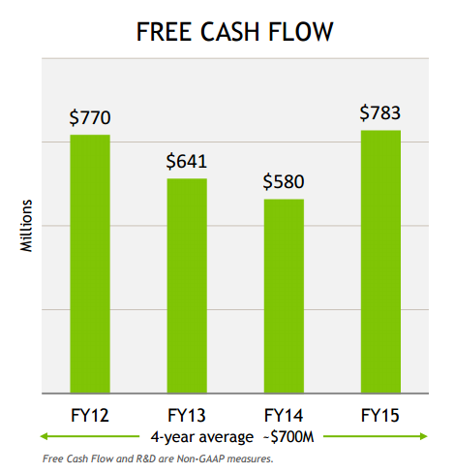

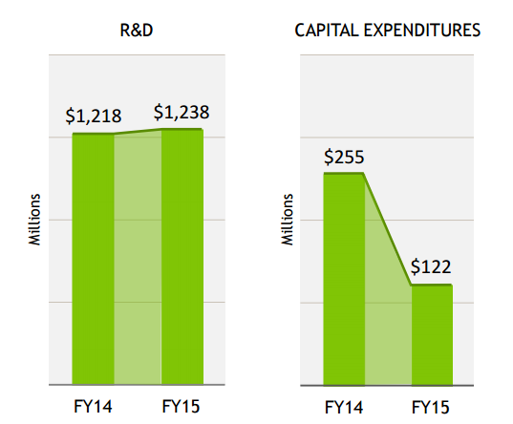

Success and Results of Freed up Cash Flow

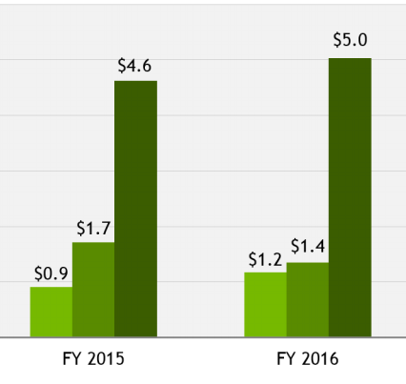

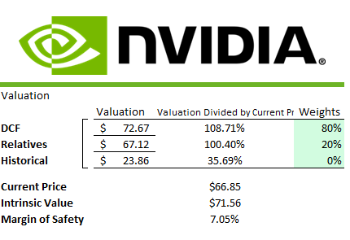

**Cost of Goods Sold**

Cost of goods sold was projected from a percent of revenue. Cost of goods sold have remained relatively constant as a percent of revenue over the past five years and we projected these costs to slowly increase NVDA continues to maintain their gaming market owner ship and invest in its newer products. As they have seen growth with their Datacenter and Automotive products NVidia should be able to maintain growth easily.

**Capital Expenditures**

Capital expenditures was projected from a percent of revenue. To project the years after we reverted back to a historical average as a percentage of revenue. Since research and innovation is essential to Nvidia the projection of capital expenditures is mostly related to developments needed in their other more complex or niche products.

**Terminal Growth**

We use a terminal value of **3%.** Inflation is expected to grow at a rate around 1% annually and U.S. GDP to continue to grow between 2% and 3% for the foreseeable future.

**Historical Model**

The other valuation model we used was a historical earnings model. A 3year and 5 year average was calculated with P/E ratios and used our expected FY17 EPS of $1.42. Nvidias extreme growth in the last year has noticeably affected my projected value per share.

This incident of growth last year made it very hard for me to value my Historical model higher any sort percentage in the final intrinsic evaluation of the future price per share as the evaluation is purely destroyed from the 2016 year. The Historical model presented a value of **$23.86** per common share. The comparable model has a weighting of 0% in the final evaluation.

**Comparable Model**

The competitors selected for the comparable model are Advanced Micro Devices (AMD), Intel (INTC), and ATI Technologies (ATI). Other comparable companies for Nvidia were hard to find as some of them were held privately, and because of the simple lack of competitors for what NVDA specifically provides. Nvidia is most notably larger than other competitor, except for Intel. However even though Intel operates very similarly they are nowhere to as good of a GPU Provider than Nvidia is. There are also products that both Intel and Nvidia individually provide that the others do not. Since there was a lack of comparable companies with missing statistics for some of the ratios it was hard for me to rate this model highly. The Comparable model presented a value of **$67.12** per common share. The comparable model has a weighting of 20% in the final evaluation.

**Investment Summary**

I recommend a strong BUY for Nvidia. This is because of them being the industry leader in their video gaming products while being invested into many of the upcoming futures in technology, such as deep learning, artificial intelligences, automobile development, mobile development and much more. Nvidia’s GPU products and branding has served to be a very strong back bone for their company while they develop further into the some of the futures in computing. This giving Nvidia many long term potential I see that while they are already creating short term catalysts for themselves such as beating other competitors such as AMD in performance as well as beating their own projected price targets. Lastly Nvidia has seen significant growth over the last five years from their increasing demand, and they are positioned perfectly to strengthen their other product lines.

With a calculated intrinsic value of $71.56 per share, and a margin of safety of 7.05%, I would recommend a BUY on Nvidia.